The 'Interesting' Deals feature in aaBridge
Written by Roger Pfister roger@RogerPf.com http://RogerPf.com/aaBridge
On the aaBridge opening Welcome page of is a large Play Bridge button.
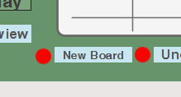
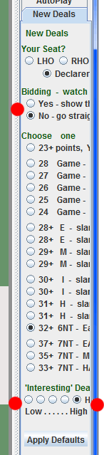
Click on this to open the Play Bridge window. On the left hand side (slightly down a fraction) is the New Board button. Click this to start a new board.
On the right hand side of the Play Bridge window is a column showing New Deal options. You can stop the display of the bidding with the Bidding – watch option (single red dot).
Below that is the Choose one option which is the main selector for the type and shape of hand that you would like aaBridge to deal for you. The image on the right shows 32+ 6NT - ... as selected.
( Suggestion try the setting 31+ H - slam 4-4, 4-3 )
Below that is the 'Interesting' Deal Selector option, (shown by two red dots).
There are 5 possible settings. When you click New Board aaBridge will deal many hands and after rejecting those that do not match the shape and point count you have selected, it will (depending on your selection) try to remove hands it regards and less interesting. The right most option rejects the most hands.
How to use (just a suggestion)
After clicking on New Board click on the Show button (to the right of the East hand). Now count top tricks to see if the contract can easily be made. Include taking any finesses that you can see will work and dropping singleton Kings and doubleton Queens, easy ruffs etc. If it looks easy click New Board and do the same again.
When you think you have one that is not so simple, for safety click Save (top right). Now, click Hide (was labelled as Show) and play it out against the computer. With luck you may have hit an interesting endplay or even a squeeze.
<end document>

